Creating a Blog!

$ rails new blog

$ cd blog

$ rails s

*go to <http://localhost:3000/>*

^c

$ rails generate controller Welcome index

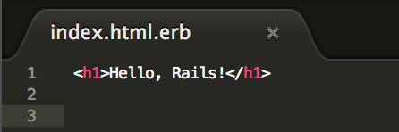

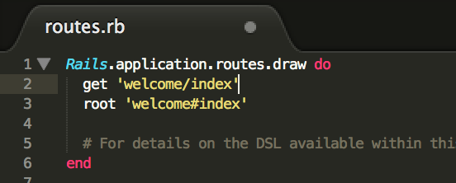

$ rails s

*go to <http://localhost:3000/>*

^c

$ rake routes

$ rails generate controller Articles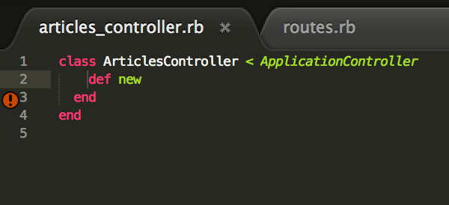

$ ra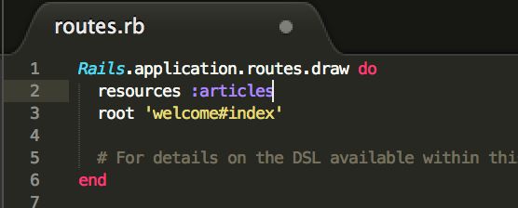ils s

*go to <http://localhost:3000/>*

*create a file app/views/articles/new.html.erb*

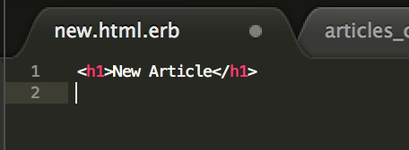

*go to <http://localhost:3000/articles/new>*

*add this code into app/views/articles/new.html.erb:*

<%= form_for :article, url: articles_path do |f| %>

<p>

<%= f.label :title %><br>

<%= f.text_field :title %>

</p>

<p>

<%= f.label :text %><br>

<%= f.text_area :text %>

</p>

<p>

<%= f.submit %>

</p>

<% end %>

*go to <http://localhost:3000/articles/new>*

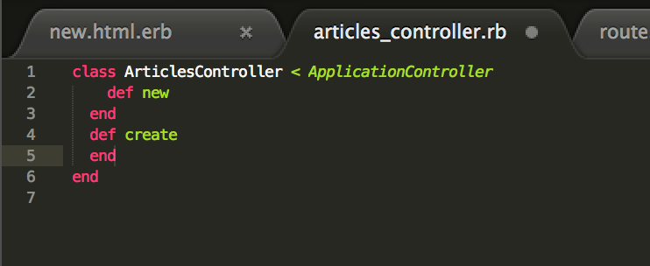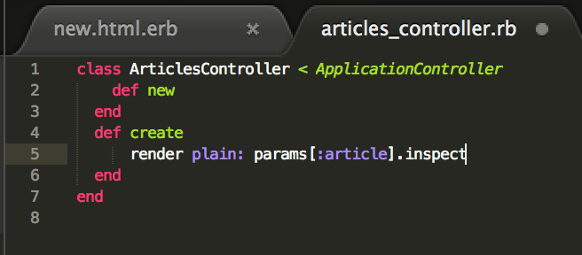

$ bin/rails generate model Article title:string text:text

*look into db/migrate/YYYYMMDDHHMMSS_create_articles.rb*

$ rails db:migrate

*add to app/controllers/articles_controller.rb :*

def create

@article = Article.new(params.require(:article).permit(:title, :text))

@article.save

redirect_to @article

end

*add to app/controllers/articles_controller.rb*

def show

@article = Article.find(params[:id])

end

*create a new file app/views/articles/show.html.erb*

*then add this*

<p>

<strong>Title:</strong>

<%= @article.title %>

</p>

<p>

<strong>Text:</strong>

<%= @article.text %>

</p>